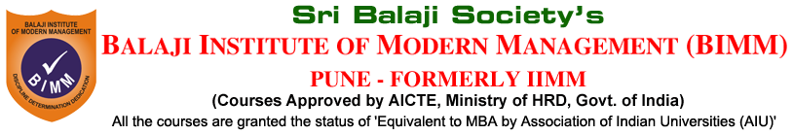

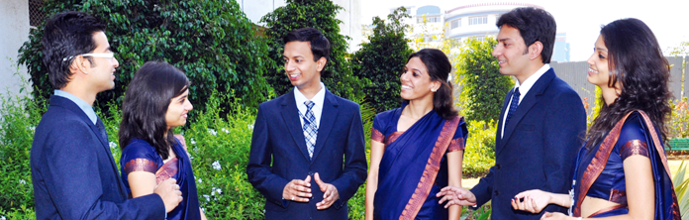

WHY BIMM

Stepping Stones to Success IIMM-s

What makes IIMM's credibility remarkable is that it was born as recently as in 1999, and yet it is already being counted amongst the top ranking B-schools of India graded as A+ by 'Business India' : **The Indian Institute of Modern Management (IIMM), Pune has craved a niche for itself in the sea of management institutes if India, through the three D's-discipline, Dedication and Determination that act as fraternity.** Thus, bringing about a favorable organizational climate to shape them into committed business management students and promising future managers in the competitive corporate world. What Ices IIMM's credibility remarkable is that it was born as recently as in 1999, and yet it is already being counted amongst the top ranking B-schools of India Graded as A+ By 'Business India'. Top 25 B-Schools by 'Outlook' and No.1 B-school in Pune by 'Business World'. The godfather of Sri Balaji Group of Institutions, including IIMM, is Dr. (Col) A. Balasubramanian, a well known educationalist known for his total commitment to the course of students, a visionary who realized, to build future managers for which an educational institute needs to go beyond note and examinations.

The moment the student steps into the institute as a fresher, a 10 day 'induction program' provides him a curtain raiser to the challenging days that are in store for him, for the next two years. Students of IIMM and all its sister institutions of Sri Balaji Society, Pune like Indian Centre for Telecom and Management (ICTM), Indian Centre for International Business (ICIB) and Indian Centre for Management And HRD (ICMHRD) also go through the same orientation that prepares them for a new and dynamic life. Here, personality development and exposure to the industry, which would be their next destination one that is encompassed with stringent requirements, which only well trained students can fulfill; if they have to survive and excel in competitive world, since performance is the only criteria for progress.

Undoubtedly, the IIMM is the cradle of leadership for the corporate world. Like managers in the industry who hardly count their Sundays for letting their hair down, the students in our institutes attend classes and hold activities, seven days a week, that is 365 days in a year. The clock of guidance does not stop here anytime. Besides, empowerment of students is the main thrust of the IIMM. Therefore, a report card is regularly sent to them, so that they can rest in peace that a responsible institute is taking care and shaping their child. It always encourages feedback from the parents. Lastly, placements are the USP of the IIMM. Over a 100 companies, many of them leading ones in different spheres of the corporate world, have recruited students from this campus and are very satisfied.

FULL TIME COURSES

The course structure at BIMM is designed to be pragmatic, dynamic and future ready. It is a by-product of industry-institute interface. The most updated course curriculum has stood the test of the time repeatedly and the same is updated periodically to ensure that the students are multi-skilled and are fully equipped to meet the challenging needs of competitive business environment.

BIMM offers the following Two-Year full-time Post Graduate Diploma in Management (PGDM) programmes, (equivalent to MBA Degree). It may be noted that even the IIMs offer PGDM only.

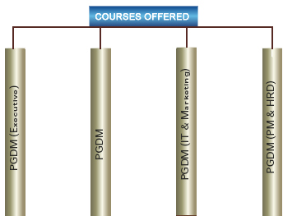  
**Two Year Full -Time Autonomous Post Graduate Diploma   
Programmes in Management offered by BIMM**

|  |  |  |
| --- | --- | --- |
| **S.No.** | **Course** | **Qualitative Requirement** |
| 1. | **PGDM  (Executive Batch)** | **Scope**: Those with adequate and appropriate industry experience will be presented for lateral placements with higher salary as compared to others as we hope them to be placed at higher level.  **Specialisations Offered**: Sales and Marketing (Including Retail & Insurance), Finance and Financial Services, Operations and Supply Chain Management including Logistics and Systems.  **Eligibility**: Candidates should have a minimum of 50% marks in graduation from any statutory University (45% for reserved category) and three (3) to five (5) years of industrial work experiences in the field of sales, marketing, human resource, finance, operations, systems and related areas of management in the industry on full time basis are eligible to apply for our PGDM - Executive Batch (Full Time).Applicants with less than five (5) years of work experience could apply through PGDM (Fresher's Batch) |
| 2. | **PGDM** | **Specialisations Offered:** Sales and Marketing (Including Retail & Insurance), Finance and Financial Services, Operations and Supply Chain Management including Logistics and Systems.  **Eligibility:** Candidates should have a minimum of 50% marks in graduation from any statutory University (45% for reserved category). However bonus marks will be given to relevant full time industrial experience and higher percentage of marks. |
| 3. | **PGDM  (IT & Marketing)** | **Focus:** A full fledged program offering specialization in Systems as well as Sales & Marketing.  **SAP Training** – S & D Module and ABAP will also be offered at a nominal fee, to be charged additionally, to selected students enhancing chances of placements as SAP consultants. (This training is a very expensive one if sought outside.)  **Eligibility:** Candidates should have a minimum of 50% marks in graduation from any statutory University (45% for reserved category). However bonus marks will be given to relevant full time industrial experience and higher percentage of marks. **Only Engineers** are eligible to take admission in this course. |
| 4. | **PGDM  (PM & HRD)** | It is a specialist programme in Personnel Management & Human Resource Development including Labour Laws offering excellent scope in the sphere of Human Resources Management in the Industry.  **Eligibility:** Candidates should have a minimum of 50% marks in graduation from any statutory University (45% for reserved category). However bonus marks will be given to relevant full time industrial experience and higher percentage of marks. 50% of the seats are reserved for Engineers. |